ExperimentNo.1.2

**Student Name:** Akash Singh **UID:** 22MCC20092

**Branch:** MCA**–**CCD **Section/Group:** MCD-1/B

**Semester:** III **Date of Performance:** 30th Aug 23

**Subject Name:** DevOps Process Automation Lab **Subject Code:** 22CAP-745

# Aim/Overview of the practical:

* 1. Create a new file named UID_Name.txt in your local repo and add some content in the file and push it to the remote repository.
  2. Manage to create two new branches using Git. Two branches must be named as your UID and Name respectively.
  3. Now, after creating branches, UID_Name.txt file must be available in Branch UID. Make some changes in the file present in Branch UID.
  4. After this, come back to your Master branch and merge the file with Branch UID file. If you face any conflicts, remove it.
  5. Create a new file named as Name.txt in Branch Name. Now try to merge it with Branch UID file. Will it be merged or not? show after implementing it.

# Code for practical: (a)

**Step 1 :** Make a new directory in your local system. After that move into newly created directory.

**Step 2 :** Make the directory a git directory by using **git init.**

**Step 3 :** After initializing directory as a git directory make a new file 22MCC20092_Akash.txt and add some content in it, by using echo command tocreate and add content into file.

**echo “this text is added in main branch” >> 22MCC20092_Akash.txt**.

**Step 4 :** Rename the default master branch into main branch using **git branch -M main. Step 5 :** After that add and commit the file.

**Step 6 :** After commit link remote repository to local git repository.

**Step 7 :** After successful commit push all the changes into remote repository.





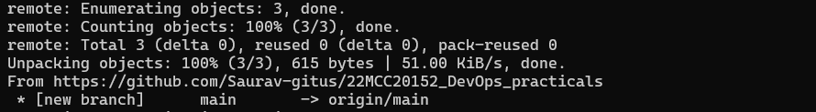

# Code for practical: (b)

**Step 1 :** Use **git branch** command to create 2 new branches.

**git branch 22MCC20092 git branch AkashSingh**

# Code for practical: (c)

**Step 1 :** To make changes in **22MCC20092_Akash.txt** in **22MCC20157** branch first we have to checkout to **22MCC20092** branch.

**Step 2 :** After checkout use echo command to append more content inside

**22MCC20092_Akash.txt.**

**echo “this text is added in 22MCC20092 branch” >> 22MCC20092_Akash.txt**

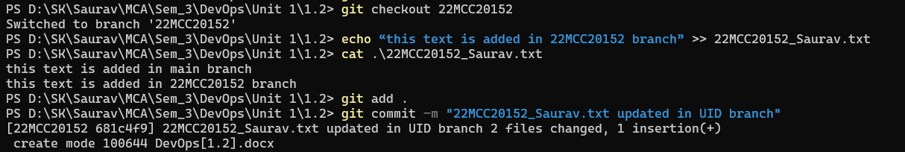

# Code for practical: (d)

**Step 1 :** Return to main branch using **git checkout main** command.

**Step 2 :** To merge **22MCC20092** branch with main use **git merge 22MCC20092**

command**.**

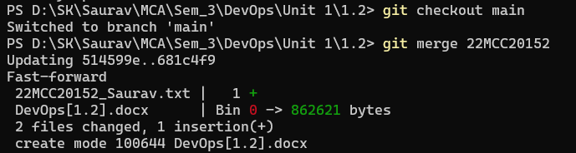

# Code for practical: (e)

**Step 1 :** To create a new file in **AkashKumar** branch first we have to checkout to the branch.

**Step 2 :** After **checkout** use echo command to create and add content into the file.

**Step 3 :** After that add and commit all changes in **AkashKumar** branch and checkout to main branch.

**Step 4 :** Now merge the **AkashKumar** branch with **22MCC20092** as we did before.

**Yes, it merges successfully.**